Whitley County, IN Community Health Assessment

This report was supported by the Cooperative Agreement Number 5U58CD001-308-02 from The Centers for Disease Control and Prevention. Its contents are solely the responsibility of the authors and do not necessarily represent the official views of The Centers for Disease Control and Prevention.

 

**Purdue Healthcare Advisors**

**1435 Win Hentschel Blvd  
West Lafayette, IN 47906**

**(765) 496-1911**

**1/17/2013**

**[Insert LHD letter here]**

Table of Contents

EXECUTIVE SUMMARY 5

INTRODUCTION 7

Report Organization 7

SOCIODEMOGRAPHIC PROFILE 9

Population Demographics 9

Population Characteristics 10

Population Growth 10

Age Distribution 11

Age Trends 11

Race and Ethnicity 12

Grandparents 15

Household Composition 16

Housing Characteristics 17

Housing Costs 18

Residence Patterns 19

Income 20

Household Income Levels 21

Employment 22

Poverty 23

Education 24

COUNTY HEALTH RANKINGS 25

COUNTY HEALTH PROFILE 29

Leading Causes of Death 29

Heart Disease 30

Cancer 31

Chronic Lower Respiratory Diseases 32

Risk Factors 33

Diabetes 34

Obesity 39

Physical Activity and Nutrition 44

Hypertension 50

Smoking 51

Substance Abuse 54

Personal Safety 57

Maternal and Child Health 58

Births 59

Teen Births 60

Low Birth Weight 61

HEALTHCARE ACCESS AND UTILIZATION 62

Health Insurance Coverage 62

Professional Shortage and Medically Underserved Areas 63

Medicaid 68

Hospital/Community Healthcare Facilities and Resources 69

# EXECUTIVE SUMMARY

Overall, Whitley County has a lower incidence of disease and chronic health conditions in several categories compared to the rest of Indiana. However, in some instances, the mortality rate and incidence for health conditions are higher in Whitley County compared to the state. There are also some health disparities identified for Whitley County. This Community Health Assessment is organized into two sections: (1) Sociodemographic Profile, and (2) County Health Profile.

**Current Health Trends and Issues**

* ***Population Growth.*** Whitley County has had consistent population growth since 1960. In the last decade, the population increased by 8.4%, while the population in Indiana increased by 6.6%. The fastest growing age group in Whitley County in the last decade was residents 45 – 64 years of age (38.5%).
* ***Growth in Minority Populations.*** The Hispanic/Latino population in Whitley County grew from 0.9% of the total population in 2000 to 1.5% of the population in 2010. The proportions of Blacks, American Indians, and Asians also increased during this time period.
* ***Housing.*** Of the 412 grandparents living with their own grandchildren less than 18 years of age in Whitley County, 47.8% were responsible for their caretaking. In 2010, of the 13,246 households, 32% were non-family households, and 17% of residents rented their residence.
* ***Income.*** From 2000 to 2010, the per capita income for residents of Whitley County decreased from $33,624 to $31,750.
* ***Unemployment Rate.*** The Whitley County 2011 annual average unemployment rate (8.7%) was lower than Indiana’s rate (9.0%), and ranks 56th out of the 92 counties.
* ***Poverty.*** Over the past decade, the percentage of the population living in poverty increased from 4.9% to 6.8% in Whitley County, and increased from 9.5% to 13.5% in Indiana.
* ***Educational Attainment.*** Of the adult population in Whitley County, 41% earned a high school degree (or the equivalent), and 49% has at least some college education.
* ***Cause of Death.*** According to the Indiana State Department of Health, the major causes of death in Whitley County in 2010 were: 1) cardiovascular diseases (94 deaths), 2) cancer (76 deaths), 3) all other diseases (42 deaths), 4) chronic lower respiratory diseases (22 deaths), and 5) Alzheimer’s Disease (12 deaths).
* ***Cardiovascular Disease*.** The age-adjusted rate of death due to other diseases of the heart is higher in Whitley County than Indiana. In Whitley County, the numbers of deaths from other diseases of the heart and stroke are notably higher for females than males.
* ***Cancer***. With an age-adjusted rate of 190.69, Whitley County has a higher cancer mortality rate than Indiana (187.62).
* ***Diabetes*.** County-level CDC estimates of diagnosed diabetes among adults 20 years of age or older in Whitley County, using an age-adjusted percentage, show a gradually increasing trend of diagnosed diabetes from 7.4% in 2004 to 7.7% in 2009. However, this rate is lower than the state rate of 9.1%.
* ***Obesity.*** Overweight is defined as having a BMI ranging from 25.0 to 29.9, and obese is defined as having a BMI greater than or equal to 30.0. A trend of increasing overweight from 26.5% in 2004 to 32.3% in 2009 is noted in Whitley County among adults > 20 years of age.
* ***Sedentary Lifestyle***. According to the CDC, National Diabetes Surveillance System, in 2009, one fifth of Whitley County residents (20.1%) did not engage in any leisurely physical activity and were considered to have a sedentary lifestyle. In 2004, the rate was 27.8%.
* ***Smoking.*** According to 2010 data from the Behavioral Risk Factor Surveillance System, the adult smoking rate (21.2%) is the lowest it has ever been in Indiana. Even with this improvement, Indiana continues to be a state with one of the highest rates of smoking in the nation, with the current U.S. prevalence rate for smoking being 17.3%. More than a million Hoosiers still smoke and the rate for men (23.3%) remains higher than for women (19.3%). In Whitley County, the prevalence of smoking in 2008-2010 was 15.3%, which was lower than the state (23.4%) and the national (17.9%) rates during that time period.
* ***Clandestine Meth Labs.*** During the last decade, the number of meth lab seizures peaked at 8 in 2005 in Whitley County. In 2010, 7 meth labs were seized.
* ***Maternal and Child Health.*** The percent of pregnant women who smoked during pregnancy in Whitley County decreased from 19.1% in 2006 to 18.3% in 2010. In Whitley County, 33.3% of live births in 2010 were to unmarried mothers, as compared to 26.0% five years ago.
* ***Healthcare Access and Utilization.*** In 2012,Whitley County was ranked by the University of Wisconsin and Robert Wood Johnson Foundation as the 15th healthiest county of all 92 counties in Indiana. The county has several health-related facilities, including the Parkview Whitley Hospital, the Whitley County Health Department, and the Bowen Center for Human Services.

# INTRODUCTION

## Report Organization

This report is organized into two sections:

* The *Sociodemographic Profile* provides information on a number of social and economic demographic indicators for Whitley County using data gleaned from existing public databases.
* The *County Health Profile* provides information on the overall health of Whitley County using data gleaned from existing public databases. Much of information presented in this section compares county-level data to state-level data. First, some of the leading causes of death are evaluated. Second, some key health indicators for Whitley County residents are explored. Third, the current status of maternal and child health is evaluated. Finally, the status of Whitley County residents’ access to healthcare is examined.

**SOCIODEMOGRAPHIC PROFILE**

# SOCIODEMOGRAPHIC PROFILE

## Population Demographics

Whitley County was formed in 1838. It was named for Col. [William Whitley](http://en.wikipedia.org/wiki/William_Whitley), who was killed in the American victory at the [Battle of the Thames](http://en.wikipedia.org/wiki/Battle_of_the_Thames) in the [War of 1812](http://en.wikipedia.org/wiki/War_of_1812).

As of the 2010 census, the Whitley County population was 33,292. The county is approximately 338 square miles in size, with 99 persons per square mile, compared to the Indiana average of 182 persons per square mile. It is bordered by Noble, Allen, Huntington, Whitley, and Kosciusko Counties. The county seat is Columbia City.

In 2012,Whitley County was ranked by the University of Wisconsin and Robert Wood Johnson Foundation as the 15th healthiest county of all 92 counties in Indiana.

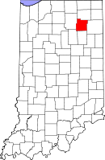

1University of Wisconsin Population Health Institute. (2012). County Health Rankings 2012. Retrieved from [www.countyhealthrankings.org](http://www.countyhealthrankings.com)

## Population Characteristics

## 

### Population Growth

Table 1 below displays population changes in Whitley County over the past 50 years. The county population has consistently increased over time. During the past decade, the population of Whitley County increased by 8.4%, compared to a 6.6% increase for Indiana. In 2010, the population change was attributed to domestic migration (+21), international migration (+1), and natural increase (+32). The 2011 population estimate of Whitley County was 33,392.

Table 1. Whitley County Population Changes, 1960–2010

|  |  |  |  |  |
| --- | --- | --- | --- | --- |
| Year | Whitley | Change | Indiana | Change |
| 1960 | 20,954 | NA | 4,662,498 | NA |
| 1970 | 23,395 | +11.6% | 5,193,669 | +11.4% |
| 1980 | 26,215 | +12.1% | 5,490,224 | +5.7% |
| 1990 | 27,651 | +5.5% | 5,544,159 | +1.0% |
| 2000 | 30,707 | +11.1% | 6,080,485 | +9.7% |
| 2010 | 33,292 | +8.4% | 6,483,802 | +6.6% |

*Source: U.S. Census Bureau*

Table 2. Population Changes by City/Town over 1,000 residents, 1990 – 2010

|  |  |  |  |  |  |  |  |
| --- | --- | --- | --- | --- | --- | --- | --- |
|  | | | | Change  1990-2010 | | Change  2000-2010 | |
| City/Town | 1990 | 2000 | 2010 | # | % | # | % |
| Columbia City | 5,706 | 7,077 | 8,750 | +3044 | +53.3% | +1,673 | +23.6% |
| Churubusco | 1,781 | 1,666 | 1,796 | +15 | +0.8% | +130 | +7.8% |
| South Whitley | 1,482 | 1,782 | 1,751 | +269 | +18.2% | -31 | -1.7% |

*Source: STATS Indiana*

### Age Distribution

In 2010, 43.7% of Whitley County’s population was 45 years old and older, as compared to 39.5% in Indiana. Approximately 24.6% of Whitley County’s 2010 population was younger than

18 years of age, as compared to 24.8% in Indiana. According to the US Census Bureau, the median age in Whitley County increased from 36.9 years of age in 2000 to 40.1 years in 2010.

Figure 1. Population by Age Group, 2010

*Source: U.S. Census Bureau*

### Age Trends

From 2000 to 2010, the population under 45 years of age decreased by 4.1%, while the population 45 years of age and older increased by 30.4%.

Table 3. Whitley County Residents’ Age Distribution, 2000 and 2010

|  |  |  |  |
| --- | --- | --- | --- |
| Age | 2000 | 2010 | Change |
| 0-4 years | 2,101 | 2,084 | -0.8% |
| 5-17 years | 6,112 | 6,099 | -0.2% |
| 18-24 years | 2,486 | 2,573 | +3.5% |
| 25-44 years | 8,866 | 8,003 | -9.7% |
| 45-64 years | 7,138 | 9,884 | +38.5% |
| 65+ years | 4,004 | 4,649 | +16.1% |

*Source: U.S. Census Bureau*

### Race and Ethnicity

A detailed description of Whitley County’s population by race/ethnicity can be seen in Tables 4-7.

According to the U.S. Census Bureau, in 2010 Whites accounted for 97.6% of Whitley County’s population followed by Blacks (0.3%), American Indians (0.3%), and Asians (0.3%). Of note, is that 132 individuals or 0.4% of the population of Whitley County is some other race, undefined by the U.S. Census Bureau. Additionally, the Hispanic or Latino population comprises 1.5% of the total population in Whitley County, with Mexican accounting for 1.2% of that 1.5%.

Table 4. Population Totals for Whitley County by Race, 2000 and 2010

|  |  |  |  |  |  |
| --- | --- | --- | --- | --- | --- |
| Race | 2000 | Percent (%) | 2010 | Percent (%) | Change |
| One Race | 30,531 | 99.4 | 32,914 | 98.9 | +7.8% |
| White | 30,205 | 98.4 | 32,479 | 97.6 | +7.5% |
| Black or African American | 57 | 0.2 | 99 | 0.3 | +73.7% |
| American Indian and Alaskan Native | 110 | 0.4 | 92 | 0.3 | -16.4% |
| Asian | 55 | 0.2 | 105 | 0.3 | +90.9% |
| Asian Indian | 5 | 0.0 | 21 | 0.1 | +320.0% |
| Chinese | 20 | 0.1 | 34 | 0.1 | +70.0% |
| Filipino | 12 | 0.0 | 25 | 0.1 | +108.3% |
| Japanese | 6 | 0.0 | 9 | 0.0 | +50.0% |
| Korean | 3 | 0.0 | 5 | 0.0 | +66.7% |
| Vietnamese | 0 | 0.0 | 2 | 0.0 | NA |
| Other Asian | 9 | 0.0 | 9 | 0.0 | 0.0% |
| Native Hawaiian and Other Pacific Islander | 13 | 0.0 | 7 | 0.0 | -46.2% |
| Native Hawaiian | 6 | 0.0 | 1 | 0.0 | -83.3% |
| Guamanian or Chamorro | 2 | 0.0 | 0 | 0.0 | -100.0% |
| Samoan | 1 | 0.0 | 6 | 0.0 | +500.0% |
| Other Pacific Islander | 4 | 0.0 | 0 | 0.0 | -100.0% |
| Some Other Race | 91 | 0.3 | 132 | 0.4 | +45.1% |
| Two or More Races | 176 | 0.6 | 378 | 1.1 | +114.8% |
| White and American Indian or Alaskan Native | NA | NA | 150 | 0.5 | NA |
| White and Asian | NA | NA | 69 | 0.2 | NA |
| White and Black or African American | NA | NA | 89 | 0.3 | NA |
| White and Some Other Race | NA | NA | 39 | 0.1 | NA |

*Source: U.S. Census Bureau*

Table 5. Race alone or in combination with one or more other races, 2000 and 2010

|  |  |  |  |  |  |
| --- | --- | --- | --- | --- | --- |
| Race | 2000 | Percent  (%) | 2010 | Percent (%) | Change |
| White | 30,380 | 98.9 | 32,852 | 98.7 | +8.1% |
| Black or African American | 90 | 0.3 | 199 | 0.6 | +121.1% |
| American Indian and Alaskan Native | 200 | 0.7 | 259 | 0.8 | +29.5% |
| Asian | 84 | 0.3 | 184 | 0.6 | +119.0% |
| Native Hawaiian and Other Pacific Islander | 18 | 0.1 | 28 | 0.1 | +55.6% |
| Some Other Race | 118 | 0.4 | 177 | 0.5 | +50.0% |

*Source: U.S. Census Bureau*

Figure 2. Race alone or in combination with one or more other races, 2010

*Source: U.S. Census Bureau*

The U.S. Census data indicates that Whitley County’s Hispanic/Latino population grew from 0.9% of the total population in 2000 to 1.5% in 2010. There was a slight decrease in the proportion of Whites (from 98.9% to 98.7%), and increases in the proportions of Blacks (from 0.3% to 0.6%), American Indians (from 0.7% to 0.8%), and Asians (from 0.3% to 0.6%). The proportion of Native Hawaiians in Whitley County remained the same from 2000 to 2010.

Table 6. Whitley County Hispanic or Latino, 2000 and 2010

|  |  |  |  |  |  |
| --- | --- | --- | --- | --- | --- |
| Hispanic or Latino | 2000 | Percent  (%) | 2010 | Percent (%) | Change |
| Hispanic or Latino (of any race) | 276 | 0.9 | 515 | 1.5 | +86.6% |
| Mexican | 201 | 0.7 | 397 | 1.2 | +97.5% |
| Puerto Rican | 12 | 0.0 | 34 | 0.1 | +183.3% |
| Cuban | 0 | 0.0 | 3 | 0.0 | NA |
| Other Hispanic or Latino | 63 | 0.2 | 81 | 0.2 | +28.6% |
| Not Hispanic or Latino | 30,431 | 99.1 | 32,777 | 98.5 | +7.7% |

*Source: U.S. Census Bureau*

Table 7. Whitley County Hispanic or Latino and Race, 2000 and 2010

|  |  |  |  |  |  |
| --- | --- | --- | --- | --- | --- |
| Hispanic or Latino and Race | 2000 | Percent  (%) | 2010 | Percent (%) | Change |
| Hispanic or Latino | 276 | 0.9 | 515 | 1.5 | +86.6% |
| White alone | NA | NA | 332 | 1.0 | NA |
| Black or African American alone | NA | NA | 3 | 0.0 | NA |
| American Indian and Alaskan Native alone | NA | NA | 16 | 0.0 | NA |
| Asian alone | NA | NA | 0 | 0.0 | NA |
| Native Hawaiian and Other Pacific Islander  alone | NA | NA | 0 | 0.0 | NA |
| Some Other Race alone | NA | NA | 110 | 0.3 | NA |
| Two or More Races | NA | NA | 54 | 0.2 | NA |
| Not Hispanic or Latino | 30,431 | 99.1 | 32,777 | 98.5 | +7.7% |
| White alone | 30,040 | 97.8 | 32,147 | 96.6 | +7.0% |
| Black or African American alone | NA | NA | 96 | 0.3 | NA |
| American Indian and Alaska Native alone | NA | NA | 76 | 0.2 | NA |
| Asian alone | NA | NA | 105 | 0.3 | NA |
| Native Hawaiian and Other Pacific Islander  alone | NA | NA | 7 | 0.0 | NA |
| Some Other Race alone | NA | NA | 22 | 0.1 | NA |
| Two or More Races | NA | NA | 324 | 1.0 | NA |

*Source: U.S. Census Bureau*

### Grandparents

Based on the U.S. Census Bureau’s American Community Survey*, in 2010, 412 grandparents in Whitley County were living with their own grandchildren under the age of 18. A total of 197 (47.8%) of the 412 who were living with their grandchildren were responsible for their caretaking. Of these grandparents, 64.5% were female and 68.0% were married.

*The American Community Survey (ACS) is a relatively new survey conducted by the U.S. Census

Bureau. It uses a series of monthly samples to produce annually updated data for the same small

areas (census tracts and block groups) formerly surveyed via the decennial census long-form

sample. Initially, 5 years of samples will be required to produce these small-area data. Once the

Census Bureau has collected 5 years of data, new small-area data will be produced annually. The

Census Bureau also will produce 3-year and 1-year data products for larger geographic areas.

### Household Composition

The U.S. Census Bureau’s American Community Survey indicated that the average household size for Whitley County residents was 2.47 persons in 2010. Whitley County had a total of 13,246 households. Family households accounted for 68% of all households in Whitley County. Married-couple families comprised 58% of all households. Nonfamily households made up 32% of all households in Whitley County. A householder living alone comprised 27% of all households.

Figure 3. Types of Households in Whitley County, 2006-2010

*Source: American Community Survey*

### Housing Characteristics

During the period of 2006-2010, Whitley County had a total of 14,110 housing units, 6% of which were vacant. Of the total housing units, 82% were single-unit structures, 10% were multi-unit structures, and 8% were mobile homes. Of the total housing units, 28% have been built in the county since 1990.

Figure 4. Types of Housing Units in Whitley County, 2006-2010

*Source: American Community Survey*

### Housing Costs

For the period of 2006 to 2010, the median monthly housing cost was $1,114 for mortgaged owners, $350 for nonmortgage owners and $562 for renters in Whitley County. Twenty-seven percent of owners with mortgages, 12% of owners without mortgages, and 50% of renters in Whitley County spent 30% or more of household income on housing. Fifty-seven percent of residents have a home mortgage, 26% own their home without a mortgage burden, and 17% rent their residence.

Figure 5. Occupants with a Housing Cost Burden in Whitley County, 2006-2010

*Source: American Community Survey*

### Residence Patterns

Between 2006 and 2010, 12% of the population moved within/to Whitley County. Specifically, 6% moved between residences in Whitley County, 4% moved from another county in Indiana, 2% moved from another state, and 0% (52 individuals) moved from abroad.

Figure 6. Residence patterns in Whitley County, 2006-2010

*Source: American Community Survey*

### Income

According to 2010 figures from the US Census Bureau, Whitley County’s median income was $49,989, compared to the state’s median income of $44,616. This represents a 5.2% increase in median income in Whitley County from 2000 to 2010. As displayed in Figure 7, per capita income increased from 1980 to 2000, but decreased between 2000 and 2010 (from $33,624 to $31,750). As shown in Table 8, for all levels of education, increasing income is noted with increasing levels of education, and differences in median income are noted between males and females in Whitley County.

Figure 7. Whitley County, Per Capita Personal Income*, 1980-2010

(Adjusted for Inflation)

*Source: STATS Indiana*

Table 8. Median Earnings by Educational Attainment for 25 Years of Age and Over

(In 2010 Inflation-Adjusted Dollars)

|  |  |  |  |
| --- | --- | --- | --- |
| Education Attainment | Total | Male | Female |
| Less than High School Graduate | $21,810 | $32,034 | $16,349 |
| High School Graduate (or equivalent) | $28,387 | $35,386 | $20,576 |
| Some College or Associate’s Degree | $31,757 | $44,006 | $24,439 |
| Bachelor’s Degree | $39,746 | $47,028 | $27,003 |
| Graduate or Professional Degree | $59,559 | $75,188 | $55,386 |
| OVERALL MEDIAN | $31,209 | $39,895 | $22,615 |

*Source: American Community Survey*

*Per capita personal income is calculated as the personal income of the residents of a given area divided by the resident population of that area.

### Household Income Levels

The 2010 American Community Survey data indicate that the largest percentage of household incomes (25%) for Whitley County fell between $50,000 and $74,999. Eighty-one percent of Whitley County households received earnings and wages, 27% received Social Security income, and 19% received retirement income.

Figure 8. Household Income Levels, 2010

*Source: American Community Survey*

### Employment

Research demonstrates that socioeconomic status in general, and income in particular, are predictors of health status.3 Such research also demonstrates that while loss of income has an impact on health status, persistent poverty is an even stronger predictor of health status in low-income individuals.4 In 2011, the Whitley County total labor force was estimated at 17,607, of which 1,540 were unemployed. The Whitley County 2011 annual average unemployment rate (8.7%) was lower than Indiana’s rate (9.0%), and ranks 56th out of the 92 counties.

Figure 9. Whitley County, Indiana, and U.S. Unemployment Rates, 2006-2011

(Not Seasonally Adjusted, Annual Average)

*Source: STATS Indiana*

According to the American Community Survey, 2.9% of the Whitley County civilian employed population 16 years and over worked in agriculture, forestry, fishing and hunting, and mining. Also, 53.9% worked outside of the county. Furthermore, among the civilian population 16 to 64 years of age, 10.3% were disabled, and of those, 45.4% were employed and 54.6% were not employed.

3 Lantz, P. M., House, J. S., Lepowski, J. M., Williams, D. R., Mero, R.P., & Chen J. (1998). Socioeconomic factors, health behaviors, and mortality. *Journal of the American Medical Association, 279*, 1703–1708.

4 McDonough, P., Duncan, G. J., Williams, D. R., & House, J. S. (1997). Income dynamics and adult mortality in the US, 1972–1999. *American Journal of Public Health, 87*, 1476–1483.

### Poverty

The 2010 U.S. Census Bureau’s American Community Survey data indicated that 6.8% of Whitley County’s total population was living below the federal poverty guidelines, compared to 13.5% for Indiana. Included in the Whitley County population living below the poverty level is 7.1% of individuals under 18 years of age, 7.6% of individuals 65 years of age and over, and 5.1% of all families. Of all households in Whitley County, 5.9% had received Food Stamp/SNAP Benefits in the past 12 months.

Table 9. Estimates of Persons and Youth in Poverty for Whitley County and Indiana, 2000 & 2010

|  |  |  |  |  |
| --- | --- | --- | --- | --- |
| **Population** | **Whitley County** | | **Indiana** | |
|  | **2000** | **2010** | **2000** | **2010** |
| Individuals living in Poverty (all ages) | 4.9% | 6.8% | 9.5% | 13.5% |
| Youth under 18 years living in Poverty | 5.3% | 7.1% | 11.7% | 18.5% |
| Individuals ≥ 65 years living in Poverty | 6.2% | 7.6% | 7.7% | 7.7% |
| Families living in Poverty | 3.3% | 5.1% | 6.7% | 9.6% |

*Source: American Community Survey*

### Education

The 2010 U.S. Census data indicate that in Whitley County, 10% of adults have less than a high school diploma, 41% earned a high school degree (or the equivalent), 23% have some college education, 10% have an Associate’s degree, 11% earned a Bachelor’s degree, and 5% have a graduate or professional degree. Taken together, nearly half of the adult population in Whitley County has at least some college education.

Figure 10. Whitley County Educational Attainment Estimates by Percentage, 2010

*Source: American Community Survey*

# COUNTY HEALTH RANKINGS

In 2003, the Robert Wood Johnson Foundation and the University of Wisconsin Population Institute began a collaborative venture called the Mobilizing Action Toward Community Health (MATCH) project. One element of this project is the County Health Rankings.5 Using data from a myriad of governmental agencies (e.g., Centers for Disease Control and Prevention, Federal Bureau of Investigation, National Center for Education Statistics); the County Health Rankings provide standings for counties in each of the 50 states. Each year, every county is given a global health rank within their respective state that is comprised of rankings for mortality, morbidity, and four health domains: health behaviors, clinical care, social and economic factors, and physical environment (see figure below).

Figure 11. County Health Rankings Model

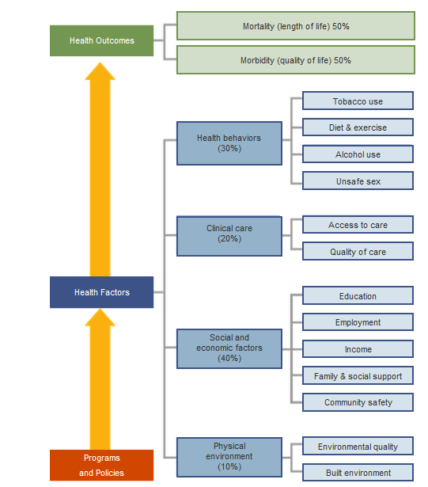

*Source: County Health Rankings model ©2010 UWPHI*

5University of Wisconsin Population Health Institute. (2010). *County Health Rankings 2010.* Retrieved from www.countyhealthrankings.com

The goal of the County Health Rankings is to provide data that compels and mobilizes local and state officials to address any barriers to quality healthcare access and care for all residents. Overall, Whitley County was ranked 15th in Indiana. Table 10 shows the 2012 rankings (out of Indiana’s 92 counties) for each of the health domains for Whitley County.

Table 10. Whitley County Health Rankings, 2012

|  |  |  |  |  |  |
| --- | --- | --- | --- | --- | --- |
| **Health Outcomes**  **Ranked 15th** | | **Health Factors**  **Ranked 17th** | | | |
| **Mortality** | **Morbidity** | **Health Behaviors** | **Clinical Care** | **Social and Economic Factors** | **Physical Environment** |
| Premature Death | Poor or Fair Health | Adult Smoking | Uninsured | High School Graduation | Air Pollution – Particulate Matter Days |
|  | Poor Physical Health Days | Adult Obesity | Primary Care Physicians | Some College | Air Pollution – Ozone Days |
|  | Poor Mental Health Days | Physical Inactivity | Preventable Hospital Stays | Unemployment | Access to Recreational Facilities |
|  | Low Birth Weight | Excessive Drinking | Diabetic Screening | Children in Poverty | Limited Access to Healthy Foods |
|  |  | Motor Vehicle Crash Death Rate | Mammography Screening | Inadequate Social Support | Fast Food Restaurants |
|  |  | Sexually Transmitted Infections |  | Children in Single-Parent Households |  |
|  |  | Teen Birth Rate |  | Violent Crime Rate |  |
| **Ranked 17th** | **Ranked 13th** | **Ranked 30th** | **Ranked 34th** | **Ranked 13th** | **Ranked 67th** |

Table 11. Whitley County Health Rankings by Year

|  |  |  |  |
| --- | --- | --- | --- |
|  | **2010** | **2011** | **2012** |
| **HEALTH OUTCOMES** | 7 | 9 | 15 |
| Mortality | 6 | 13 | 17 |
| Morbidity | 12 | 10 | 13 |
| **HEALTH FACTORS** | 11 | 14 | 17 |
| Health Behaviors | 36 | 25 | 30 |
| Clinical Care | 24 | 24 | 34 |
| Social and Economic Factors | 9 | 18 | 13 |
| Physical Environment | 40 | 36 | 67 |

**COUNTY HEALTH PROFILE**

# COUNTY HEALTH PROFILE

## Leading Causes of Death

## 

This section details the leading causes of death for Whitley County. The total number of deaths in 2010 for Whitley County was 304, for an age-adjusted rate of 778.00. Indiana’s age-adjusted death rate was 816.22. The top five leading causes of death for Whitley County are as follows: (1) Major Cardiovascular Diseases, (2) Cancer, (3) All Other Diseases, (4) Chronic Lower Respiratory Diseases, and (5) Alzheimer’s Disease. This order is comparable to that for Indiana, except for Alzheimer’s Disease.

Much of the data in this section compares Whitley County’s mortality rates to those for the state of Indiana. All data presented in this section, unless otherwise noted, were captured from the Indiana State Department of Health. Unless otherwise noted, all of the mortality rates in this section are age-adjusted deaths per 100,000 people. Age-adjusted mortality rates provide rates of death while controlling for changes in the age distribution over time. Age-adjustment also affords comparison of death rates among communities with different age distributions.

Table 12. Top Ten Leading Causes of Death Based on Total Number of Deaths in Whitley County

|  |  |  |  |  |
| --- | --- | --- | --- | --- |
| **Rank** | **Cause of Death** | **Indiana**  **Age-Adjusted**  **Rates** | **Whitley Age-Adjusted**  **Rates** | **Whitley**  **No. of**  **Deaths** |
| 1 | Major Cardiovascular Diseases | 253.12 | 240.26 | 94 |
| 2 | Cancer | 187.62 | 190.69 | 76 |
| 3 | All Other Diseases (see Appendix A) | 141.67 | 104.73 | 42 |
| 4 | Chronic Lower Respiratory Diseases | 55.19 | 55.75 | 22 |
| 5 | Alzheimer’s Disease | 27.64 | U | 12 |
| 6 | Influenza and Pneumonia | 16.72 | U | 11 |
| 7 | Diabetes | 22.67 | U | 10 |
| 8 | Kidney Disease | 21.82 | U | 8 |
| 9 | Symptoms, Signs and Abnormal Clinical and Laboratory Findings | 9.54 | U | 7 |
| 10 | All Other and Unspecified Accidents and Adverse Effects | 27.13 | U | 6 |

*Source: 2010 Indiana Mortality Report, Indiana State Department of Health, Epidemiology Resource Center*

* Numbers less than 5, including 0, have been suppressed to protect confidentiality.

U The rate is unstable when there are fewer than 20 deaths.

### Heart Disease

### 

Heart disease is the number one cause of death for Americans and has been for the last 80 years.6 Heart disease includes congenital heart defects, coronary artery disease, high blood pressure, heart failure, and stroke.7 In 2006, heart disease accounted for approximately one out of every 2.9 deaths nationwide. Data on the mortality rate for heart disease in 2005 showed that about 2,400 Americans died daily–an estimated one death for every 37 seconds.8

The age-adjusted rate of death due to other diseases of the heart is higher in Whitley County than Indiana as demonstrated in the table below. In Whitley County, the numbers of deaths from other diseases of the heart and stroke are notably higher for females than males.

Table 13. Age-adjusted Mortality Rates for Heart Disease by Race

|  |  |  |  |  |  |  |  |  |  |
| --- | --- | --- | --- | --- | --- | --- | --- | --- | --- |
| **Diagnosis** | **Indiana Age-Adjusted Rates** | **Whitley Age-Adjusted Rates** | **Whitley**  **No. of Deaths** | **White** | | | **Black** | | |
| **All** | **Male** | **Female** | **All** | **Male** | **Female** |
| Ischemic heart diseases | 115.41 | 100.94 | 39 | 39 | 28 | 11 | - | - | - |
| Other diseases of the heart | 67.68 | 79.19 | 31 | 31 | 13 | 18 | - | - | - |
| Stroke | 44.27 | U | 14 | 14 | 5 | 9 | - | - | - |
| Atherosclerosis | 4.05 | U | 5 | 5 | - | - | - | - | - |
| Hypertensive heart disease with or without renal disease | 7.76 | U | - | - | - | - | - | - | - |
| Other diseases of the circulatory system | 7.44 | U | - | - | - | - | - | - | - |
| Essential hypertension and hypertensive renal disease | 6.51 | U | - | - | - | - | - | - | - |

*Source: 2010 Indiana Mortality Report, Indiana State Department of Health, Epidemiology Resource Center*

* Numbers less than 5, including 0, have been suppressed to protect confidentiality.

U The rate is unstable when there are fewer than 20 deaths.

6Greenlund, K. J., Giles, W. H., Keenan, N. L., et al. (2006). Heart disease and stroke mortality in the 20th century. In: J. Ward & C. Warren (Eds). *Silent victories: the history and practice of public health in twentieth century America.* Oxford, England: Oxford University Press.

7 Llyod-Jones, D., Adams, R. J., Brown, T. M. et al. (2010). Heart disease and stroke statistics—2010 update. A report from the American Heart Association. *Circulation, 121*, 1-70.

8 *Cardiovascular disease statistics*. (n.d.). Retrieved from http://www.americanheart.org/presenter.jhtml?identifier=4478

### Cancer

### 

Cancer is the second leading cause of death in the United States, accounting for approximately one out of four deaths each year.9 While the 5-year relative survival rate for cancer has improved over the years, the mortality rate associated with cancer remains fairly high.

With an age-adjusted rate of 190.69, Whitley County has a higher cancer mortality rate than Indiana (187.62). The table below displays the most recent data available for Whitley County on some of the various forms of cancer.

Table 14. Age-Adjusted Cancer Mortality Rates for Different Forms of Cancer

|  |  |  |  |
| --- | --- | --- | --- |
| **Type of Cancer** | **Indiana Age-Adjusted Rates** | **Whitley Age-Adjusted**  **Rates** | **Whitley**  **No. of**  **Deaths** |
| Malignant neoplasm of the trachea, bronchus, and lung | 58.32 | 55.50 | 22 |
| Other malignant neoplasms | 45.56 | U | 15 |
| Malignant neoplasm of the urinary tract | 10.07 | U | 7 |
| Malignant neoplasm of the colon, rectum and anus | 16.08 | U | 6 |
| Malignant neoplasm of the prostate | 8.55 | U | 6 |
| Malignant neoplasm of the breast | 12.77 | U | 5 |
| Malignant neoplasm of the pancreas | 11.08 | U | 5 |
| Malignant neoplasm of the cervix uteri, corpus uteri, and ovary | 8.60 | U | - |
| Leukemia | 7.32 | U | - |
| Non-Hodgkin’s Lymphoma | 6.72 | U | - |
| Malignant neoplasm of the stomach | 2.55 | U | - |

*Source: 2010 Indiana Mortality Report, Indiana State Department of Health, Epidemiology Resource Center*

* Numbers less than 5, including 0, have been suppressed to protect confidentiality.

U The rate is unstable when there are fewer than 20 deaths.

9 American Cancer Society. (2009). *Cancer Facts* & *Figures 2009*. Atlanta: American Cancer Society.

### Chronic Lower Respiratory Diseases

Chronic lower respiratory diseases includes chronic bronchitis, asthma, emphysema, and other chronic lower respiratory diseases.10 Overall, Whitley County has a slightly higher mortality rate for chronic lower respiratory diseases than Indiana.

Figure 12. Age-adjusted Mortality Rates for Chronic Lower Respiratory Diseases, 2010

*Source: 2010 Indiana Mortality Report, Indiana State Department of Health, Epidemiology Resource Center*

10 National Center for Health Statistics. (2010). *Health, United States, 2009: With Special Feature on Medical Technology.* Retrieved from http://www.cdc.gov/nchs/data/hus/hus09.pdf

## Risk Factors

This section outlines the status of various factors that have been found to be predictive of or

present risk for a multitude of health problems, including chronic diseases. The presence of any of these factors or a combination of these factors may negatively impact an individual’s health

status. Substantial health research has suggested that decreasing or eliminating risk factors exponentially improves overall health and in many cases extends life expectancy.22  Many of the risk factors covered in this section are health indicators being tracked as part of the national Healthy People 2020 initiative (see <http://www.healthypeople.gov> for more information) to improve quality of life and eliminate health disparities for Americans.

22Danaei, G., Rimm E. B., Oza S., et al. (2010). The promise of prevention: The effects of four preventable risk factors on national life expectancy and life expectancy disparities by race and county in the United States. *PLoS Medicine, 7*(3). doi:10.1371/journal.pmed.1000248

### Diabetes

While diabetes is the 7th leading causes of death for Whites and the 4th leading cause of death for Blacks in Indiana, it is also a risk factor for many other physical complications and illnesses. It is estimated that 9.3% of adults, or about 450,000, in Indiana have diabetes*.* Additionally, an estimated 250,000 adults have undiagnosed diabetes in the state.

County-level CDC estimates of diagnosed diabetes among adults 20 years of age or older in Whitley County, using an age-adjusted percentage, is 7.7%. This rate is lower than the state rate of 9.1%. However, an increasing trend of diagnosed diabetes is noted in Whitley County from 2004 to 2009 as shown in Figure 14 below.

Figure 13. County-level Estimates of Diagnosed Diabetes among Adults aged ≥ 20 Years. United States, 2009

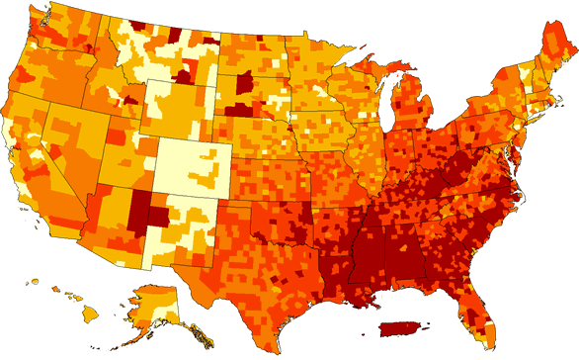

Age-adjusted percent



*Source: Centers for Disease Control and Prevention*

Figure 14. Estimates of Diagnosed Diabetes among Adults aged ≥ 20 in Whitley County, 2004- 2009*

*Source: Centers for Disease Control and Prevention*

***\*****Graph displays midpoint of range reported for CDC estimates*

Figure 15. 2004 Age-Adjusted Estimates of the Percentage of Adults with Diagnosed Diabetes in Indiana

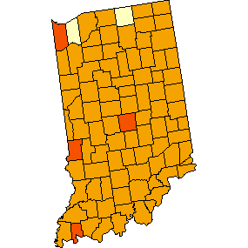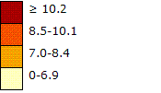

*Source: Centers for Disease Control and Prevention*

Figure 16. 2005 Age-Adjusted Estimates of the Percentage of Adults with Diagnosed Diabetes in Indiana

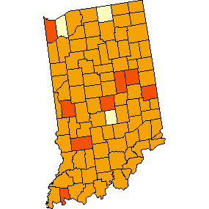

*Source: Centers for Disease Control and Prevention*

Figure 17. 2006 Age-Adjusted Estimates of the Percentage of Adults with Diagnosed Diabetes in Indiana

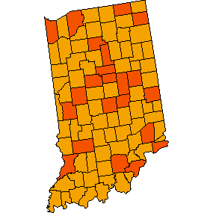

*Source: Centers for Disease Control and Prevention*

Figure 18. 2007 Age-Adjusted Estimates of the Percentage of Adults with Diagnosed Diabetes in Indiana

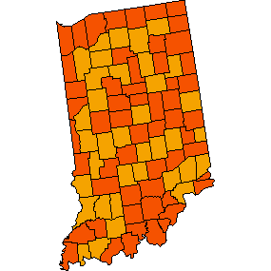

*Source: Centers for Disease Control and Prevention*

Figure 19. 2008 Age-Adjusted Estimates of the Percentage of Adults with Diagnosed Diabetes in Indiana

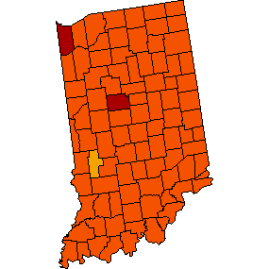

*Source: Centers for Disease Control and Prevention*

Figure 20. 2009 Age-Adjusted Estimates of the Percentage of Adults with Diagnosed Diabetes in Indiana

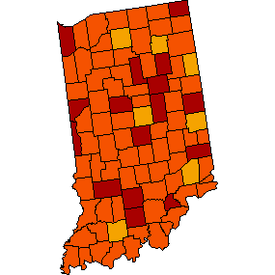

*Source: Centers for Disease Control and Prevention*

### Obesity

Obesity is a risk factor that has gained a great deal of public attention in the last decade, and is one of the key initiatives for 2020 set forth by the U.S. Surgeon General.23  It has been estimated that the percentage of obese adults in the United States has more than doubled in the last twenty years from 13.4% in 1980 to 34.3% in 2008.24  The percentage of obese children has followed a similar trend; it rose from 5% in 1980 to 17% in 2008.25 Figure 21 shows the county level estimates of obese adults aged 20 and older in 2009. A gradual trend of increasing overweight from 26.5% in 2004 to 32.3% in 2009 is noted in Whitley County as demonstrated in Figure 22.

Figure 21. County-level Estimates of Obesity among Adults aged ≥ 20, United States, 2009

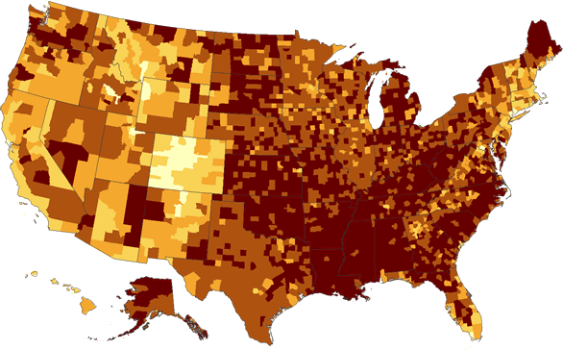

Age-adjusted percent



*Source: Centers for Disease Control and Prevention*

23 U.S. Department of Health and Human Services. (2010). *The Surgeon General’s Vision for a Healthy and Fit Nation.* Rockville, MD: U.S. Department of Health and Human Services, Office of the Surgeon General.

24 Flegal, K. M., Carroll, M. D., Ogden, C. L., & Curtin, L. R. (2010). Prevalence and trends in obesity among US adults, 1999-2008. *Journal of the American Medical Association, 303,* 235-241.

25 Ogden, C. L., Carroll, M. D., Curtin, L. R., Lamb, M. M., & Flegal, K. M. (2010). Prevalence of high body mass index in US children and adolescents, 2007-2008. *Journal of the American Medical Association, 303,* 242-249.

Figure 22. Estimates of Obesity among Adults aged ≥ 20 in Whitley County, 2004-2009*

*Source: Centers for Disease Control and Prevention*

***\*****Graph displays midpoint of range reported for CDC estimates*

Table 15. BMI

|  |  |
| --- | --- |
| **BMI** | **Weight Status** |
| Below 18.5 | Underweight |
| 18.5 – 24.9 | Normal |
| 25.0 – 29.9 | Overweight |
| 30.0 and Above | Obese |

Figure 23. 2004 Age-Adjusted Estimates of the Percentage of Adults Who Are Obese in Indiana

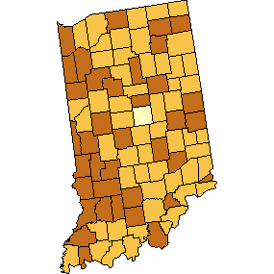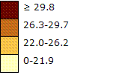

*Source: Centers for Disease Control and Prevention*

Figure 24. 2005 Age-Adjusted Estimates of the Percentage of Adults Who Are Obese in Indiana

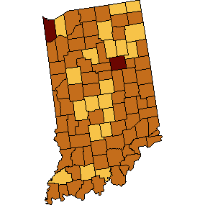

*Source: Centers for Disease Control and Prevention*

Figure 25. 2006 Age-Adjusted Estimates of the Percentage of Adults Who Are Obese in Indiana

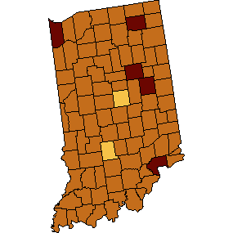

*Source: Centers for Disease Control and Prevention*

|  |
| --- |
| Figure 26. 2007 Age-Adjusted Estimates of the Percentage of Adults Who Are Obese in Indiana |

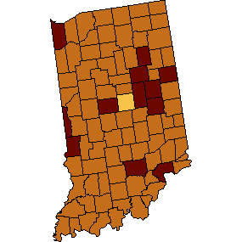

*Source: Centers for Disease Control and Prevention*

Figure 27. 2008 Age-Adjusted Estimates of the Percentage of Adults Who Are Obese in Indiana

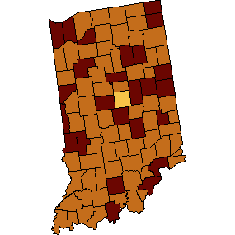

*Source: Centers for Disease Control and Prevention*

Figure 28. 2009 Age-Adjusted Estimates of the Percentage of Adults Who Are Obese in Indiana

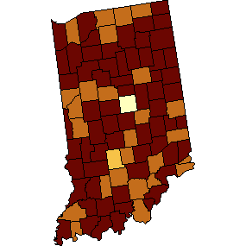

*Source: Centers for Disease Control and Prevention*

### Physical Activity and Nutrition

Physical activity and proper nutrition are essential to maintaining healthy weight and preventing disease. Physical inactivity and poor nutrition present significant risk for development of many chronic diseases such as heart disease, obesity, diabetes and cancer. Adults who are active are healthier, and are significantly less likely to develop these chronic diseases, and will have better aerobic fitness than adults who are inactive. Adults need to do two types of physical activity (aerobic and muscle-strengthening activities) each week to improve their individual health.

According to the CDC, National Diabetes Surveillance System, in 2008, one fifth of Whitley County residents (20.1%) did not engage in any leisurely physical activity and were considered to have a sedentary lifestyle. Figures 29 and 30 below display the number of adults with a sedentary lifestyle in the U.S., Indiana and Whitley County. The trend for 2004 – 2009 is also presented below.

Figure 29. Percentage of Adults with Sedentary Lifestyle, United States, 2009

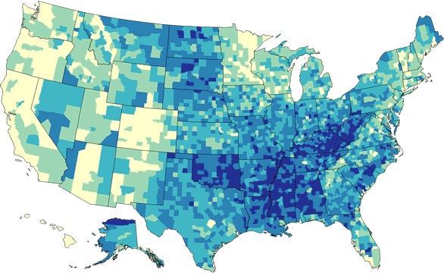

Age-adjusted percent



*Source: Centers for Disease Control and Prevention*

Figure 30. Percentage of Adults with Sedentary Lifestyle in Whitley County, 2004- 2009*

*Source: Centers for Disease Control and Prevention*

***\*****Graph displays midpoint of range reported for CDC estimates*

Figure 31. 2004 Age-Adjusted Estimates of the Percentage of Adults Who Are Physically Inactive in Indiana

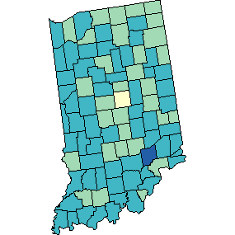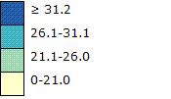

*Source: Centers for Disease Control and Prevention*

Figure 32. 2005 Age-Adjusted Estimates of the Percentage of Adults Who Are Physically Inactive in Indiana

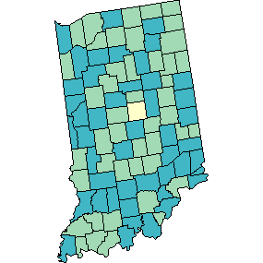 

*Source: Centers for Disease Control and Prevention*

Figure 33. 2006 Age-Adjusted Estimates of the Percentage of Adults Who Are Physically Inactive in Indiana

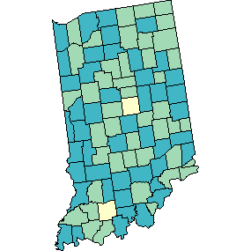 

*Source: Centers for Disease Control and Prevention*

Figure 34. 2007 Age-Adjusted Estimates of the Percentage of Adults Who Are Physically Inactive in Indiana

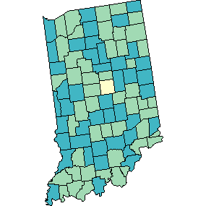 

*Source: Centers for Disease Control and Prevention*

Figure 35. 2008 Age-Adjusted Estimates of the Percentage of Adults Who Are Physically Inactive in Indiana

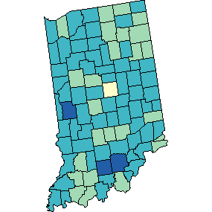 

*Source: Centers for Disease Control and Prevention*

Figure 36. 2009 Age-Adjusted Estimates of the Percentage of Adults Who Are Physically Inactive in Indiana

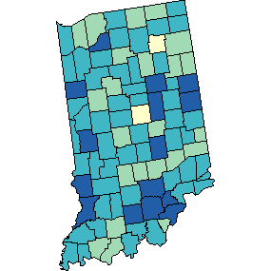 

*Source: Centers for Disease Control and Prevention*

In 2010, the CDC released a state level report entitled, “State Indicator Report on Physical Activity, 2010 Policy and Environmental Indicators.” Results for Indiana and the U.S. are provided below. At this time county-level data is not available.

Table 16. Policy and Environmental Indicators for Physical Activity, Indiana and U.S., 2010

|  |  |  |  |  |  |  |  |
| --- | --- | --- | --- | --- | --- | --- | --- |
|  | **Create or Enhance Access to Places For Physical Activity** | | | **Enhance PE and Physical Activity in Schools and Physical Activity in Child Care Settings** | | | |
|  | % youth w/parks, community centers, sidewalks in neighborhood | % census blocks w/park within ½ mile of boundary | % census blocks w/fitness center within ½ mile of boundary | Require or recommend elementary schools provide scheduled recess | Require elem., middle, high schools to teach PE | % middle and high schools that support walking or biking to and from school | Child care centers specific Physical Activity |
| **Indiana** | 43.7% | 15.2% | 13.3% | No | Yes | N/A | No |
| **U.S.** | 50.0% | 20.3% | 16.6% | 20 states | 37 states | 46 states | 8 states |

|  |  |  |  |  |
| --- | --- | --- | --- | --- |
|  | **Support Urban Design, Land Use and Transportation Policies** | | | **Develop Physical Activity**  **Public Health Workforce** |
|  | Community-scale urban design/land use policy | Street-scale urban design/land use policy | Transportation and travel policy | Number of states physical activity  full-time equivalent personnel |
| **Indiana** | No | No | No | No |
| **U.S.** | 27 states | 23 states | 36 states | 1 state |

*Source: CDC Physical Activity State Indicator Report*

### Hypertension

Hypertension or high blood pressure is a well-documented risk factor for heart disease, stroke, and many chronic illnesses. Furthermore, there are a host of risk factors for hypertension (e.g., smoking, obesity, poor nutrition). The figure below shows comparable percentages of adults with hypertension in Whitley County, Indiana, and the U.S. The percentage in Whitley County (29.3%) is higher than the state (28.5%) and the national (27.3%) percentages.

Figure 37. Percentage of Adults with Hypertension, Whitley County, Indiana, U.S. 2005-2009

*Source: Centers for Disease Control and Prevention (BRFSS) & Health Indicators Warehouse*

### Smoking

Tobacco use is the single most preventable cause of death and disease in the United States. Annually, tobacco use causes more deaths than alcohol, AIDS, car accidents, illegal drugs, murders and suicides, combined. The American Cancer Society has estimated that approximately 170,000 cancer-related deaths are attributable to tobacco use.26  Not only is smoking a risk factor for cancer, but it is also linked to many other chronic and potentially fatal illnesses. In Indiana, the impact of tobacco on Indiana is the loss of 9,700 lives each year.

According to 2010 data from the Behavioral Risk Factor Surveillance System, the adult smoking rate (21.2%) is the lowest it has ever been in Indiana. Even with this improvement, Indiana continues to be a state with one of the highest rates of smoking in the nation, with the current U.S. prevalence rate for smoking being 17.3%. More than a million Hoosiers still smoke and the rate for men (23.3%) remains higher than for women (19.3%). In Whitley County, the prevalence of smoking in 2008-2010 was 15.3%, which was lower than the state (23.4%) and the national (17.9%) rates during that time period.

Figure 38. Percentage of Adult Smokers in Whitley County, Indiana, and U.S., 2008-2010

*Source: Centers for Disease Control and Prevention (BRFSS) & Health Indicators Warehouse*

26American Cancer Society. (2009). *Cancer Facts* & *Figures 2009*. Atlanta: American Cancer Society. http://www.in.gov/isdh/tpc/files/AdultSmoking_June2010.pdf

**WHITLEY COUNTY TOBACCO FREE POLICIES**

**Hospitals and Health Care Facilities:**

• Parkview Whitley

• Bowen Center

**School Districts:**

• Whitley County Consolidated School

**Poor Mental Health**

Unlike the other risk factors discussed in this section, mental health is a mental state, not a physical indicator. Nonetheless, poor mental health can have severe physical consequences. Adults who reported that their mental health was not good (i.e., issues with stress, depression, or problems with emotions) on 14 or more days in the previous 30 days were considered to be experiencing poor mental health.

The County Health Rankings provide a county level measure of ‘poor mental health days’. The estimates provided are based on responses to the question: “Thinking about your mental health, which includes stress, depression, and problems with emotions, for how many days during the past 30 days was your mental health not good?” For each county what is presented is the average number of days a county’s adult respondents report that their mental health was not good. The measure is then age-adjusted to the 2000 U.S. population.

In Whitley County the reported number of unhealthy days was 2.3 days per month. The range in Indiana was 1.5 to 7.1 days per month, with an overall measure for Indiana of 3.6 days per month.

*Source: University of Wisconsin, County Health Rankings*

### Substance Abuse

For children, ‘family’ is the most important influence in shaping their lives. For children growing up in homes where there is substance abuse, attending schools without effective non-drug use policies and growing up in communities where drug use is not well controlled, there is a tremendous impact on their health, safety and well-being. Variables associated with elevated risk for substance abuse are presented below, including tobacco, alcohol, and clandestine meth labs. Of note is that data on prescription drug abuse is not included in this report and may be further considered when evaluating the issue of substance abuse.

Table 17. Tobacco Outlet Density and Annual Spending on Tobacco, 2009-2010

|  |  |  |  |
| --- | --- | --- | --- |
|  | **Outlets Per**  **1,000 People** | **Outlets Per 1,000**  **Youth 10-17 Years** | **Annual Spending Per Household on Tobacco** |
| Whitley County | 0.73 | 6.81 | $344 |
| Indiana | 0.77 | 7.06 | $324 |
| U.S. | --- | --- | $343 |

*Source: Indiana Prevention Resource Center*

Figure 39. Map Vulnerable Youth*, Ages 10-17, 2010

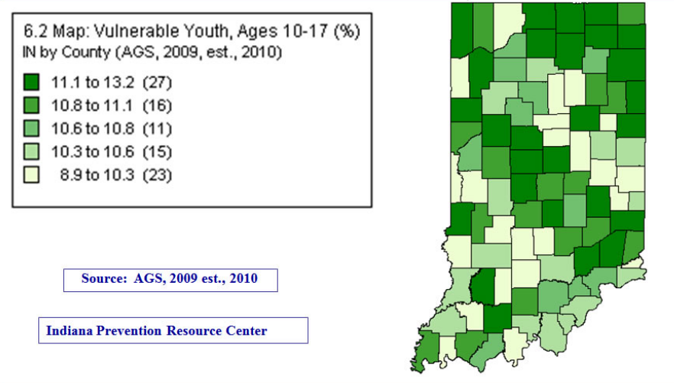

*The youth most vulnerable to sales of tobacco underage are considered to be 10-17.

This next indicator is defined as the number of alcohol sales outlets in relation to the total population. The following table shows the number of alcohol licenses; the number of licenses per 1000 18-20 year olds; and the rank of Whitley County among Indiana's 92 counties for these two variables; plus comparisons to the state.

Table 18. Alcohol Sales Outlets Per Capita in Whitley County and Indiana, 2009

|  |  |  |  |  |
| --- | --- | --- | --- | --- |
|  | **Number of Licenses** | **Licenses Per 1000 18-20 Year Olds** | **Rank Licenses Per 1000 18-20 Year Olds** | **Annual Alcohol Spending Per Household** |
| Whitley County | 66 | 51.92 | 54 | $598 |
| Indiana | 13,812 | 51.68 | -- | $578 |
| U.S. | --- | --- | --- | $642 |

*Source: Indiana Prevention Resource Center*

Methamphetamine is a drug that is highly addictive and physically damaging to the human body. However it is very simple to make and can be made in very clandestine settings in any community. Therefore, the prevalence of clandestine meth labs in Whitley County is one indicator of substance abuse as an issue in the county. Figure 40 displays the number of clandestine lab seizures in Whitley County and Indiana over the past decade. Figures 41 and 42 below compare the prevalence of clandestine meth labs in Whitley County to other Indiana counties.

Figure 40. Clandestine Meth Lab Seizures in Whitley County and Indiana

*Source: Indiana Prevention Resource Center*

Figure 41. Total Lab Busts in 2009

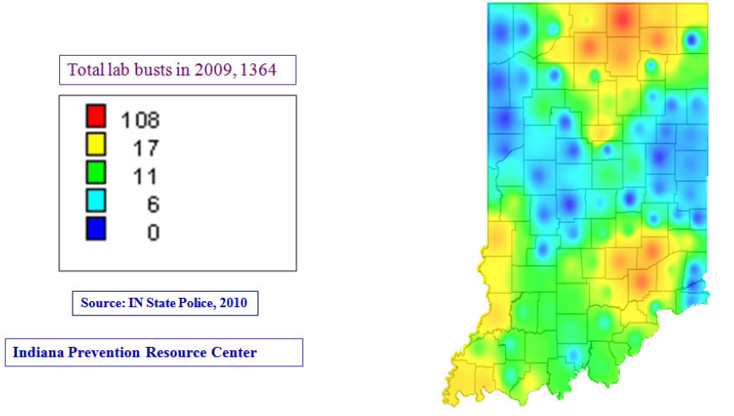

Figure 42. Total Lab Busts in 2009

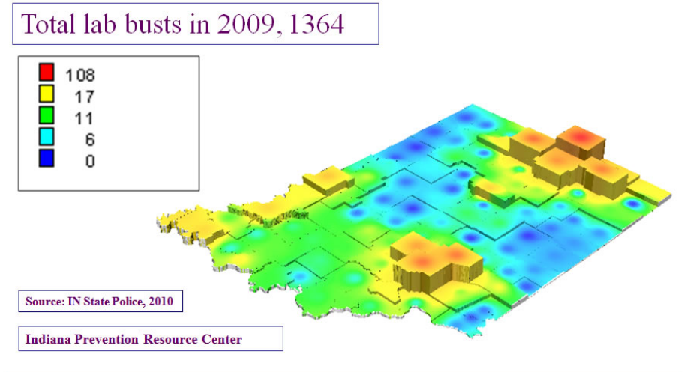

Also, in Whitley County in 2008, 122 arrests were made for driving under the influence of liquor or narcotics, 60 arrests were made for unlawful possession or sale of marijuana, and 9 arrests were made for neglect or abuse of family and children.

### Personal Safety

People prefer to live and work in geographic locations where they feel safe. The degree of criminal activity in every county has a significant influence on many aspects of life. Therefore, crime statistics are a useful insight into the character of a county and are important to consider in planning for healthy environments where people can live, work and play. Data about crimes, arrests and convictions are not collected in any one central location in the state of Indiana currently.

The AGS Crime Risk Indices displayed below describe the risk of various types of crime in Whitley County and compares the rate of crime in the county to that in the state and the U.S.

In Whitley County, the Personal Crime Index and the Property Crimes rate are much lower than the state rates. Murder, rape, robbery, and assault rates are also considerably lower than the state rates. Burglary, larceny, and motor vehicle theft rates are notably lower than the state rates.

Table 19. Crimes Risk Indices* for Whitley County, Indiana and U.S., 2009-2010

|  |  |  |  |
| --- | --- | --- | --- |
| **Crime Indices** | **Whitley County** | **Indiana** | **U.S.** |
| **Total Crime Index** | **11** | **93** | **100** |
| Personal Crime Index | 13 | 68 | 100 |
| Property Crimes | 5 | 97 | 100 |
| **Personal Crime Index** |  |  |  |
| Murder | 42 | 96 | 100 |
| Rape | 8 | 88 | 100 |
| Robbery | 4 | 72 | 100 |
| Assault | 7 | 63 | 100 |
| **Property Crimes** |  |  |  |
| Burglary | 7 | 93 | 100 |
| Larceny | 4 | 102 | 100 |
| Motor Vehicle Theft | 4 | 80 | 100 |

*Source: Indiana Prevention Resource Center*

*The Crime Risk Index describes the risk of various types of crime in a given geographic area (e.g., city or state) by comparing the rate of crime in that location to the rate of crime in the nation as a whole. The crime rate for the U.S. is set to 100 for all crimes. Hence a rate of 200 means that the risk of crime in that place is twice as high as for the nation as a whole. (Think of these numbers not as counts of criminal incidents, but as degrees of risk.)

## Maternal and Child Health

Maternal and child health includes prenatal, perinatal, and postnatal health characteristics and behaviors. In 2010, 34.2% of mothers residing in Whitley County began prenatal care after the first trimester, which was an increase from 27.9% in 2009. About 65.8% of all mothers in Whitley County, compared to 68.5% in Indiana, received prenatal care within their first trimester of pregnancy in 2010. Of the resident births in Whitley County in 2010, 7.3% were low birth weight as compared to 8.0% in Indiana. Also, 9.0% of the resident births in the county in 2010 were preterm, compared to 10.0% for Indiana.

Table 20. Whitley County Maternal and Child Health Statistics, 2006-2010

|  |  |  |  |  |  |
| --- | --- | --- | --- | --- | --- |
|  | **2006** | **2007** | **2008** | **2009** | **2010** |
| **Mortality** | | | | | |
| # Fetal Deaths | 5 | 1 | 2 | 4 | NA |
| # Infant Deaths (birth - < 1 year) | 2 | 2 | 0 | 2 | 3 |
| # Neonatal Deaths (birth - < 28 days) | 1 | 1 | 0 | 2 | 1 |
| # Post-Neonatal Deaths (28 - 364 days) | 1 | 1 | 0 | 0 | 2 |
| **Natality** | | | | | |
| # Pregnancies | 388 | 469 | 406 | 433 | 432 |
| # Live Births | 361 | 449 | 390 | 412 | 409 |
| # Teen Births (ages 15-19) | 34 | 31 | 32 | 42 | 34 |
| % Low Birth Weight (less than 2500 grams) | 8.9% | 8.5% | 6.9% | 9.0% | 7.3% |
| % Preterm Births | 10.5% | 12.2% | 10.8% | 10.0% | 9.0% |
| % PNC in 1st Trimester | 88.1% | 75.7% | 77.4% | 72.1% | 65.8% |
| % Smoked During Pregnancy | 19.1% | 21.6% | 20.8% | 18.0% | 18.3% |
| % Unmarried Mothers | 26.0% | 29.4% | 34.4% | 29.4% | 33.3% |

*Source: Indiana State Department of Health*

### Births

The number of resident births fluctuated from 2006 to 2010 in Whitley County. In Indiana, the number of births increased between 2006 and 2007, but decreased between 2007 and 2010 (see figures below). In Whitley County, 33.3% of live births in 2010 were to unmarried mothers, as compared to 26.0% five years ago. The percent of pregnant women who smoked during pregnancy in Whitley County decreased from 19.1% in 2006 to 18.3% in 2010.

Figure 43. Whitley Resident Births, 2006-2010

*Source: Indiana State Department of Health*

Figure 44. Indiana Resident Births, 2006-2010

*Source: Indiana State Department of Health*

### Teen Births

### 

Teen births are reported as births to mothers 15 to 19 years old in Indiana. Overall, the number of teen births for Whitley County has remained nearly constant over the past five years. In Indiana, the number of teen births increased between 2006 and 2007, but declined between 2007 and 2010.

Table 21. Teen Births for Whitley County and Indiana, 2006-2010

|  |  |  |  |  |  |
| --- | --- | --- | --- | --- | --- |
|  | **2006** | **2007** | **2008** | **2009** | **2010** |
| Whitley County | 34 | 31 | 32 | 42 | 34 |
| Indiana | 9,611 | 9,931 | 9,602 | 9,484 | 8,659 |

*Source: Indiana State Department of Health*

### Low Birth Weight

Infants born less than five and a half pounds, or 2500 grams, in weight are identified as being low birth weight. The Whitley County low birth weight rate fluctuated from 2006 to 2010. The Indiana rate remained nearly unchanged.

Figure 45. Percent Low Birth Weight Births for Whitley County and Indiana, 2006-2010

*Source: Indiana State Department of Health*

# HEALTHCARE ACCESS AND UTILIZATION

## Health Insurance Coverage

## 

A variety of health insurance coverage options exist, including employer-provided plans, independently-purchased plans, health savings accounts, and government-funded plans. Lack of health insurance coverage presents significant risk to those needing health care services. According to a Harvard Medical School study, approximately 45,000 adults die each year as a result of not having health insurance coverage.27 This means that an American dies every 12 minutes of every year because they have no health care insurance coverage.

Based on the U.S. Census Bureau Small Area Health Insurance Estimates, in 2010, approximately 14.5% of those less than 65 years of age were uninsured in Whitley County. For those under the age of 19 years, the percent uninsured was 8.7%, and for all Whitley County residents 18-64 years of age, the uninsured rate was 17.0%.

27 Wilper, A. P., Woolhandler, S., Lasser, K. E., McCormick, D., Bor, D. H., & Himmelstein, D. U. (2009). Health insurance and mortality in US adults. *American Journal of Public Health, 99*, 1-7.

## Professional Shortage and Medically Underserved Areas

The U.S. Department of Health and Human Services (DHHS) has designated a particular branch of its organization to track health professional shortages and medically underserved areas. This branch is the Health Resources and Services Administration (HRSA).28  HRSA determines which geographic areas, populations, and/or institutions have shortages of primary care, dental or mental healthcare providers. Using strict criteria utilizing the ratios between population and number of clinicians, HRSA determines (a) if an entity has a shortage of health professionals (Health Professional Shortage Areas; HPSA) or (b) if specific areas (Medically Underserved Areas; MUA) or populations (Medically Underserved Populations; MUP) have too few primary care providers, high poverty, high infant mortality rates, or high elderly population.29

Based on the explanation above, geographic areas are assigned a score. For MUAs, scores range from 1 to 62, where the lower the score, the higher the need. If a score is not assigned, a ‘Governor’s Exception’ may also designate a MUP. Designations that are not MUAs or MUPs, are HPSAs, where the higher the score, the higher the need.

The figures below show the Medically Underserved Areas and the Primary Care, Dental, and Mental Health Professional Shortage Areas for Indiana and Whitley County.

28 Wilper, A. P., Woolhandler, S., Lasser, K. E., McCormick, D., Bor, D. H., & Himmelstein, D. U. (2009). Health insurance and mortality in US adults. *American Journal of Public Health, 99*, 1-7.

29 Department of Health and Human Services. Health Resources and Services Administration. *HPSA by State and County.* Retrieved from http://bhpr.hrsa.gov/shortage/

Figure 46. Indiana Medically Underserved Areas and Populations, 2012



Source: ISDH and Shortage Designation Branch, HRSA, U.S. Department of Health and Human Services

Figure 47. Indiana Primary Care Health Professional Shortage Areas and Populations, 2012



Source: ISDH and Shortage Designation Branch, HRSA, U.S. Department of Health and Human Services

Figure 48. Indiana Dental Health Professional Shortage Areas and Populations, 2012



Source: ISDH and Shortage Designation Branch, HRSA, U.S. Department of Health and Human Services

Figure 49. Indiana Mental Health Professional Shortage Areas, 2012



Source: ISDH and Shortage Designation Branch, HRSA, U.S. Department of Health and Human Services

## Medicaid

Medicaid is a federal and state-funded program enacted by Congress in 1965 that provides healthcare resources to low income families. Indiana is ranked 33rd of all states of Medicaid population in the U.S.30

30 Kaiser Commission on Medicaid and the Uninsured. (2010*). Health Management Associates from State Medicaid Enrollment Reports*. Retrieved from <http://www.kff.org/medicaid/upload/8050-02.pdf>

## Hospital/Community Healthcare Facilities and Resources

Parkview Whitley Hospital

Whitley County Health Department

Otis R. Bowen Center for Human Services, Inc.